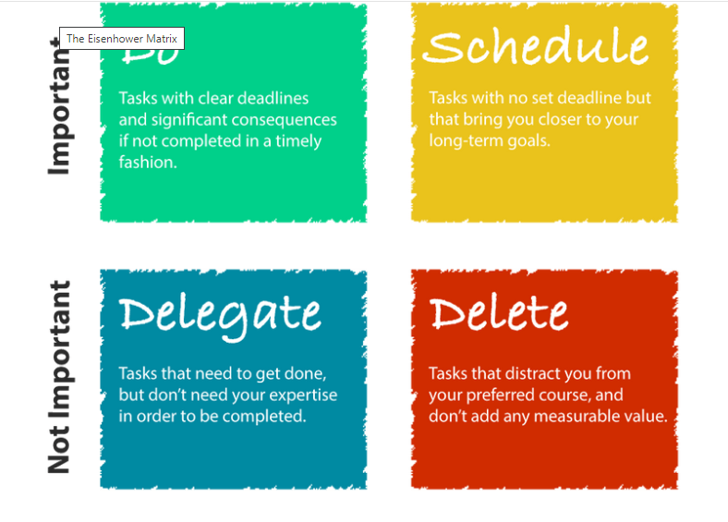

* **Career**
* **Financial**
* **Education**
* **Family**
* **Artistic**
* **Attitude**
* **Physical**
* **Pleasure**